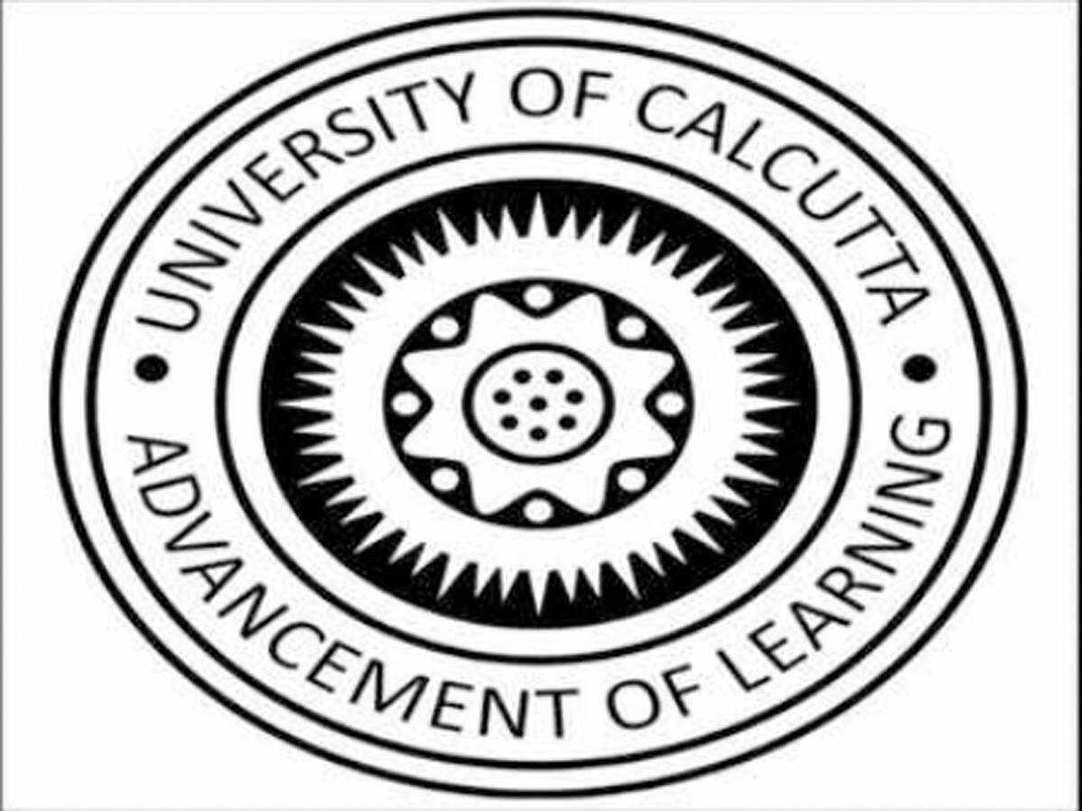
Aniket Pandey
College: Department of Law, University of Calcutta
Email: pandeyaniket2198@gmail.com
Contact Number: +91 9123966129

EDUCATIONAL QUALIFCATION
COLLEGE/SCHOOL | QUALIFICATION | CGPA/PERCENTAGE
Department of Law, University of Calcutta | Pursuing 4th year of the BA.LL. B Course | 8.17
Delhi Public School, Newtown Kolkata | Higher Senior Secondary (Class XII); Affiliated to ICSE Board | 71.33%
Delhi Public School, Newtown Kolkata | Senior Secondary (Class X); Affiliated to ISC Board | 71.55%

ADDITIONAL QUALIFICATIONS AND COURSES
COURSE | INSTITUTION | TIME PERIOD/PROGRESS
Criminal Litigation and Trial Advocacy | Law Sikho | Completed

INTERNSHIPS
R.Singh and Associates and Advocates, Kolkata [January-February, 2022: 4 weeks]
- Drafted Legal Notices to Bombay Stock Exchange in a matter involving fake trade and artificial volume creation; Assisted my mentor in drafting a complaint to Station House Officer.
- Did extensive case law research on Section 7, 8, 43, 66 and 67 of the Insolvency and Bankruptcy Code, 2016; drafted a Counter Affidavit.
Advocate Om Prakash Tiwari, Government Pleader-III- Office of the Advocate General, Jharkhand High Court, Ranchi [September-October, 2021: 4 weeks]
- Reviewed, Revised and Briefed a wide range of legal document for Mentor Advocates.
- Conducted Legal Research regarding various Service and Criminal matters.
- Assisted my mentor on various issues namely, preparing synopsis for the matter, briefing the matter to the head senior, researching case law based answers to legal questions
- Assisted my mentor in drafting letter to the Respondent Bureaucrats in Service and Civil matters.
Senior Advocate Milon Mukherjee, Calcutta High Court, Kolkata [March 2021- April 2021: 4 weeks]
- Attended depositions and court proceedings and prepared summaries on cases.
- Performed legal and general research, and drafting.
Advocate Anant Sharma, K&S Legal LLP, Work from Home [August 2020- February 2021 : 24 weeks]
- Co-drafted intensively researched twenty-five legal articles on various topics concerning Criminal Law
- Gained valuable insight into traditional topics associated with Criminal law.
- Conducted research for several important Case Laws and Judgments
Criminal Law Review, Work from Home [January 2021- February 2021: 4 weeks]
- Created highly researched legal Handbook for Laws on Criminal Appeal
- Prepared Monthly Newsletter comprising latest Criminal Law judgments
ACADEMIC ACHIEVEMENTS
- Obtained ‘A+’ grade (the highest attainable grade) in Law of Torts including Motor Vehicles [TCPL] and Political Science in the third semester final examination
- Obtained ‘A’ grade in Contract Law I in the first semester final examination
MOOT COURT EXPERIENCE

- Researcher, Calcutta University Department of Law First Intra Moot Court Competition
- Speaker (Quarter Finalist), JIS University National Moot Court Competition
- Speaker (2nd Best Memorial), Calcutta University Department of Law Second Intra Moot Court Competition.

PUBLICATIONS

- “Nullum crimen sine lege, nulla poena sine Lege”- ‘A Principle of Legality’ published in the Volume 3, Issue 1 of the Indian Legal Solution E-Journal of Constitutional and Criminal Law.
HOBBIES AND INTERESTS
Apart from internships, riding mountain bicycle and reading books on socio-religious and national topics occupy my time during vacations.

