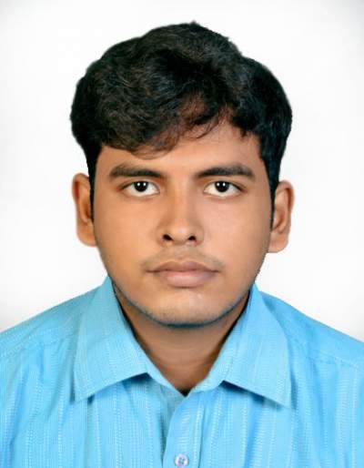
CONTACT DETAILS
Name :- Arka Sengupta
Address :- Narayanpally near Shibmandir,P.O;-Nimta
Kol:-700049(India)
Email :- arka3331@gmail.com
arka32749@gmail.com
Phone :- +917404660413
+919163061827

Academic Qualification
Name of Examination | Year of passing | Board/University | Marks obtained/CGPA
Master of Technology  (Power electronics and Drives) | 2017 | National Institute Of Technology(NIT) Kurukshetra | 8.77(78.93%)
Graduation(B.Tech in Electrical Engineering) | 2015 | Techno India College of Technology(TICT) | 8.71(79.60%)
All India Senior School certificate Examination(10+2) | 2008 | Central Board Of Secondary Education | 79.8%
All India Secondary School Examination(10th ) | 2006 | Central Board Of Secondary Education | 74.6%

Professional Experience
Name of Organization | Designation | Joining date | Release date
Sagacious Research IP | Patent Analyst | 3rd July 2017 | 27th July 2018
St Thomas College of Engineering and Technology | Assistant Professor | 1st August 2018 | Working till date

Subject of Interest
- Power Electronics and Drives
- Machine
- Power System
- Control System

Project
- Comparison of fault in Transmission line and cable with different parameter using Alternative Transient Program(ATP) Software

IEEE Conference Publication
- Cost Analysis of Distribution Network With Distributed Generation Using Long Run Incremental Cost Method
Industrial Training
- Training on transmission and distribution of electric power under West Bengal state electricity transmission company limited(WBSETCL)
- Training on Programmable Logic Controller(PLC)

Achievements
- I was the champion of junior division table tennis(doubles) at school
- I was the champion of table tennis senior division(doubles) at school
- Selected for National Defence Academy (NDA)
- Having NCC A certificate

Interests
- Playing Table Tennis
- Listening to Music

.Personal Information
Father’s Name :- Sunil Sengupta
Mother’s Name :- Mayurakshi Sengupta
Date of Birth :- 16th March 1990
Nationality :- Indian

