Curriculum Vitae
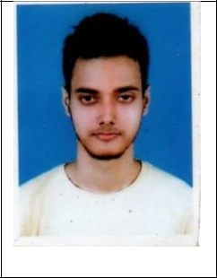

SUBHODIPTA MITRA
SON OF LATE CHANCHAL KUMAR MITRA

RESIDING AT 15 / 4 HARISAVA BANKPARK
P.O. NONACHANDANPUKUR P.S. TITAGARH
BARRACKPORE, KOLKATA - 700122
MOBILE-7278031479 / 9123861527
Email id- rjmitra98@gmail.com

OBJECTIVE:

To make a positive impact in my field of activity leading to organization growth by creative application of my value based convictions and professional divinity by putting my all efforts In the work assigned to me in an organization where I can grow along with the organization.

Education
- Completed B.A.LL.B ( 72.42%) from South Calcutta Law College, affiliated to the University of Calcutta (2015-2020)
- Passed 10+2 from Anandamath Vidyapith , West Bengal, WBCHSE ( 2011-13)
Previous Positions :
- Worked under Learned Advocate Mr. Suprabhat Bhattacharyya in the High Court at Calcutta for Period of 3(three) years

Research Skills :
- Case study and analysis
- Interpretation and Evaluation
- Finding Precedents

Soft Skills :
- Communication
- Problem solving
- Adaptability
- Critical thinking

Linguistic Skills :
- English ( Fluent)
- Bengali ( Fluent)
- Hindi ( Fluent )

Computer Skills :
- MS Office ( Word, Excel, Powerpoint)
- Email Rules

Declaration:
I hereby declare that all the information given by me is true to be the best of my knowledge.

Dated : 31st March, 2022

