Curriculum Vitae
RIA MUKHERJEE
DAUGHTER OF VIVEKANANDA MUKHERJEE RESIDING AT 19 S.N. BANERJEE ROAD DURGAPUR, PASCHIM BARDHAMAN PIN CODE 713204
MOBILE- 7439686576 / 8001534410
Email id- riamukherjee101@gmail.com

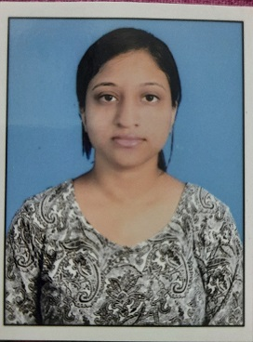

Objective
To make a positive impact in my field of activity leading to organization growth by creative application of my value based convictions and professional divinity by putting my all efforts In the work assigned to me in an organization where I can grow along with the organization.
Education
- Completed B.A.LL.B (First Class) from South Calcutta Law College under the University of Calcutta (2016-2021)
- Passed 10+2 from Carmel School, Durgapur , West Bengal, ISC Board ( 2014-16)
- Passed Secondary Examination from Aurobindo Vidya Mandir, Durgapur, West Bengal, ICSE Board (2014)

Current Position :
Legal Consultant in Fast Info Legal Services Private Limited
Previous Positions :
- Ex- National Coordinator at All India Lawyers Forum
- Worked under Learned Advocate Mr. Ranabir Roy Chowdhury in the High Court at Calcutta for Period of 1(one) year
- Internship for a period of one month in the West Bengal Human Rights Commission
- Internship for a period of 8(eight) months in the Alipore Police Court

Participation and Achievements :
- Secured 2nd position in the Debate Competition held at Debt Recovery Tribunal, Park Street, Kolkata and

Research Skills :
- Case study and analysis
- Interpretation and Evaluation
- Finding Precedents

Soft Skills :
- Communication
- Problem solving
- Adaptability
- Critical thinking

Linguistic Skills :
- English ( Fluent)
- Bengali ( Fluent)
- Hindi ( Fluent )

Computer Skills :
- MS Office ( Word, Excel, Powerpoint)
- Email Rules

Declaration:
I hereby declare that all the information given by me is true to be the best of my knowledge.

Dated : 25th April, 2022

