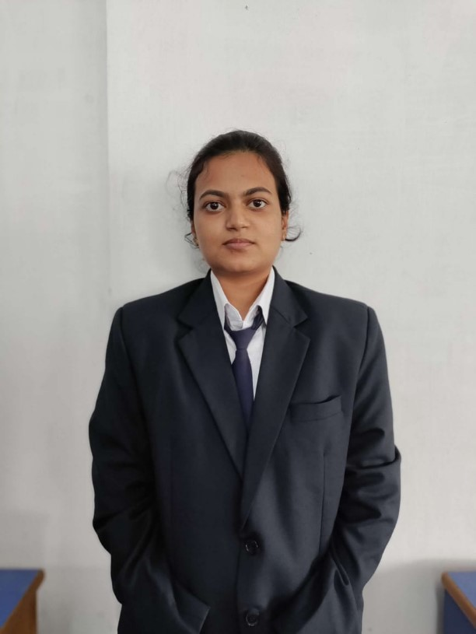
C
u
r
r
i
c
u
l
u
m
V
i
t
a
e
N
a
m
e
:
E
S
H
A
D
A
S
A
d
d
r
e
s
s
:
1
B
,
R
A
D
H
A
N
A
T
H
M
U
L
L
I
C
K
L
A
N
E
,
K
O
L
K
A
T
A
M
o
b
i
l
e
N
o
.
:
9
3
3
0
5
6
1
2
8
2
E
m
a
i
l
I
d
.
e
s
h
a
d
a
s
4
5
6
@
g
m
a
i
l
.
c
o
m
A
c
a
d
e
m
i
c
Q
u
a
l
i
f
i
c
a
t
i
o
n
s
:
Degree /  Certificate | Degree | Discipline | Institute | Board /  University | Year of  Passing | Aggregate % / CGPA
Graduation | BBA. LLB(Hons) |  | University of  Engineering  &  Management, Kolkata | University of  Engineering & Management, Kolkata | 2024
12“ | Higher Secondary |  | Kendriya  Vidayala,  Kathmandu, Nepal | CBSE | 2019 | 86%
 | Secondary |  | Kendriya  Vidayala,  Kathmandu, Nepal | CBSE | 2017 | 8.8 CGPA
Aggregate Marks mean Summation of the marks obtained in a// the subjects (including optional subjects) divided by the total marks in all subjects.
Trainings / Projects Undertaken:
Name of Institute | /
Organization |  | Project Title | Duration
Internship —
- Advocatespedia
- ASDM legal
- Voice of Barristers

PROJECT:-
Additional Qualification / Achievements / Certifications:
1. Publication of articles- wages as per the new code on wages 2019- Under voice of Barristers
Subjects of Interest:
Volunteering
Hobbies:
Writing & Reading Family Details:
Details | Name | Occupation
Father | BISHWA NATH DAS | Business
Mother | APARNA DAS | Home Maker
Sibling (Optional)
Personal Details:
Date of Birth : 25-01-2002
Gender : Female
Languages Known : English, Hindi, Nepali
Date :10-06-2022
Signature
^{Date} 11/06/2022
Place/Location
Kolkata

