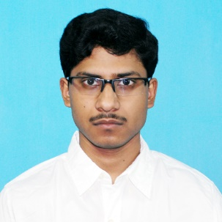 SOUMAVA RAY
Address: IA – 237, Sector – III, Salt Lake,
Kolkata – 700097, West Bengal, India

Phone number: 6289808323
Email: roy.2020rs@gmail.com

A fresher advocate in the new in the legal arena. Willing to learn from seniors and work hard. Skills include time management, attention to detail, problem solver, good communication and finally, competent in coping with adverse situations.

Languages:
- English (Read, Write and Speak) [Fluent]
- Bengali (Read, Write and Speak) [Fluent]
- Hindi (Read and Speak) [All most Fluent]

Experience: As already mentioned above I am a fresher. Looking forward to gain experience working under you. I believe I am a quick learner and will be an asset to the firm.

Education:
- Secondary Exam: Birla High School
- Higher Secondary Exam: Hariyana Vidya Mandir
- Bachelor’s Degree: Department of Law, University of Calcutta

Interests:
- Travel
- Chess
- Exercise
- Meditation
- Learning Historical Facts

