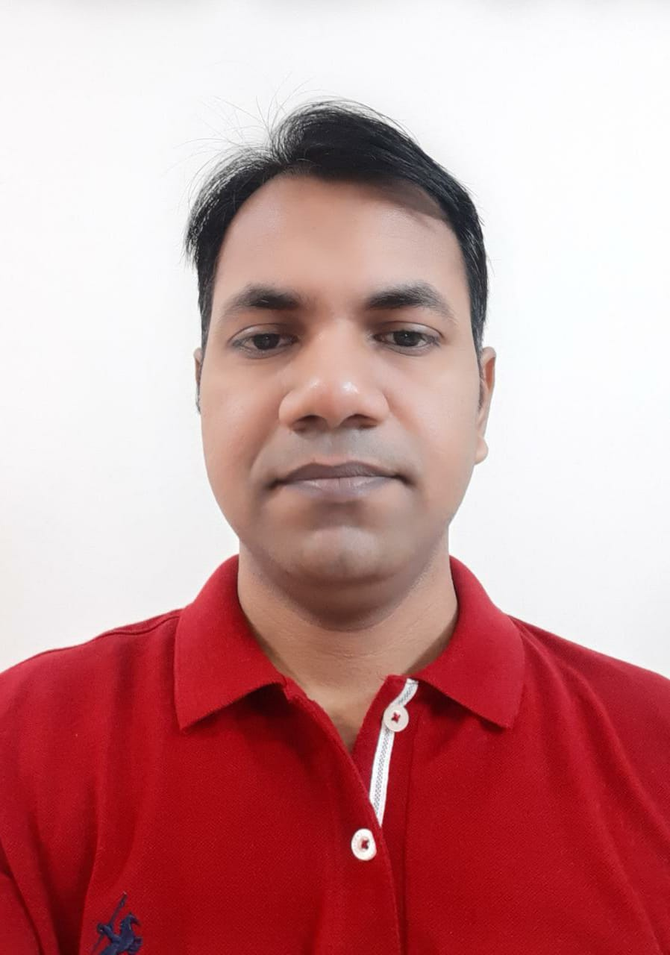 |  | UMESH KUMAR  IP PROFESSIONAL
Profile  Lastly, I worked at TT Consultants India as a TEAM LEAD since April 2022. I have 8 years of work experience in IPR. I have work knowledge of patentability searching, invalidity/ validity, infringement (EOUs), moderate proficiency in Standard essential patent in Telecom (SEP), moderately skilled in Drafting and office action. Proficiency in IPR tools like Orbit, Discover, Patbase and TI.  I also worked in different college and university as an Assistant Professor before coming to IPR.  Contact  PHONE:  +918882616725  +919625293659  EMAIL:  umesh0532@gmail.com  ADDRESS:  C/o Pankaj, Near Shri Balaji dham mandir, Kakanagar, Shamli  Uttar Pradesh (247776)  Hobbies  Guitar  Painting |  | EDUCATION  Delhi Technological University (Formerly DCE), Delhi  2011-2013  Master of Technology, VLSI Design and Embedded System  GPA 8.22 (First Division)  National Institute of Technology (NIT), Warangal  2005-2009  Bachelor of Technology, Electronics and Communication Engineering  GPA 6.64 (First Division)  WORK EXPERIENCE  TT Consultants Ind Pvt ltd as Team lead  [April 2022 to Jan 2023]  Preliminary Invalidity searching on current litigation APAC region clients.  Invalidity and Infringements  Research wire Ind Pvt ltd as Team lead  [August 2021 to April 2022]  SEP (standard essential patents infringement charting in Telecom domain)  Invalidity and Infringement  LS Davar as Senior Patent Analyst  [February 2020 to March 2021]  Worked on Office Action, Invalidity, EOU, Patentability Searches and landscape projects, Patent Drafting.  Arctic Innovation India Pvt Limited as Senior Patent Engineer  [May 2017 to February 2020]  Worked on Office Action, Invalidity, EOU, Patentability Searches and landscape projects  Worked on IP brokering related projects  CPA Global Support Services as IP Researcher  [April 2014 to May 2017]  Worked on Invalidity, EOU, Patentability Searches

PUBLICATION SUMMARY
Research Papers

- “CMOS Body Driven Quaternary Logic Generator” in International Journal of Science and Research with DOI “10.9790/4200-0114650”.
- “CNTFET Technology Based Precision Full-Wave Rectifier Using DDCC” published in International Journal of Engineering and Science.
- “Fiction Supporting Decelerated Expansion of the Universe” in International Journal of Science and Research with DOI “10.9790/4861-0214142”.
- “Patch Antenna Array Fault Modelling and Its Monitoring” in International Journal of Science and Research with DOI “10.9790/2834-0340611”.

Personal Details
Father’s Name Vikrama Ram
Mother’s Name Usha Devi
Date of Birth 25/06/1987
Place of Residence Ghazipur Uttar Pradesh India
Gender Male
Marital Status Married
Nationality Indian
Language Proficiency Hindi and English
Passport Z4085408

Declaration
I, hereby declare that all the information furnished by me is true and fare to the best of my knowledge and I shall be solely responsible for all the declaration made above.

Signature Date
(Umesh Kumar)

