MISS DISHA SOMANI
BIRLA SCHOOL OF LAW, BIRLA GLOBAL UNIVERSITY
EMAIL ADDRESS: dishasomani25@gmail.com
PHONE: +917602960818
+917865850066

OBJECTIVE :
To emerge as an important part of the organization by the achievement of a given target and to work in challenging areas that will utilize my skills and expand my knowledge.

PRESENT STATUS:
I am persuading B.B.A LL.B. (Hons) 5-year (2020-2025 course ) at Birla Global University in Bhubaneswar

Experience:
Was an intern at the honorable Odisha human rights commission
And in District court of Jhargram West Bengal under an advocate (Mr. Nilesh)

EDUCATIONAL QUALIFICATIONS
COLLEGE: Birla Global University (2020-2025)
Currenly in 4th year
West End High School (ICSE board)
West Bengal, Jhargram
ClassXII (2020)
Student of commerce
PERCENTAGE: 85%( best four)
Class X (2018)
PERCENTAGE: 69.4% (best 5)

EXTRA Qualifications
• Basics in computer

STRENGTH:
Writing Skills
Quick learner

REFERENCES
MS; Ishani Acharya , programme manager
Email: ishani.acharya@bgu.ac.in

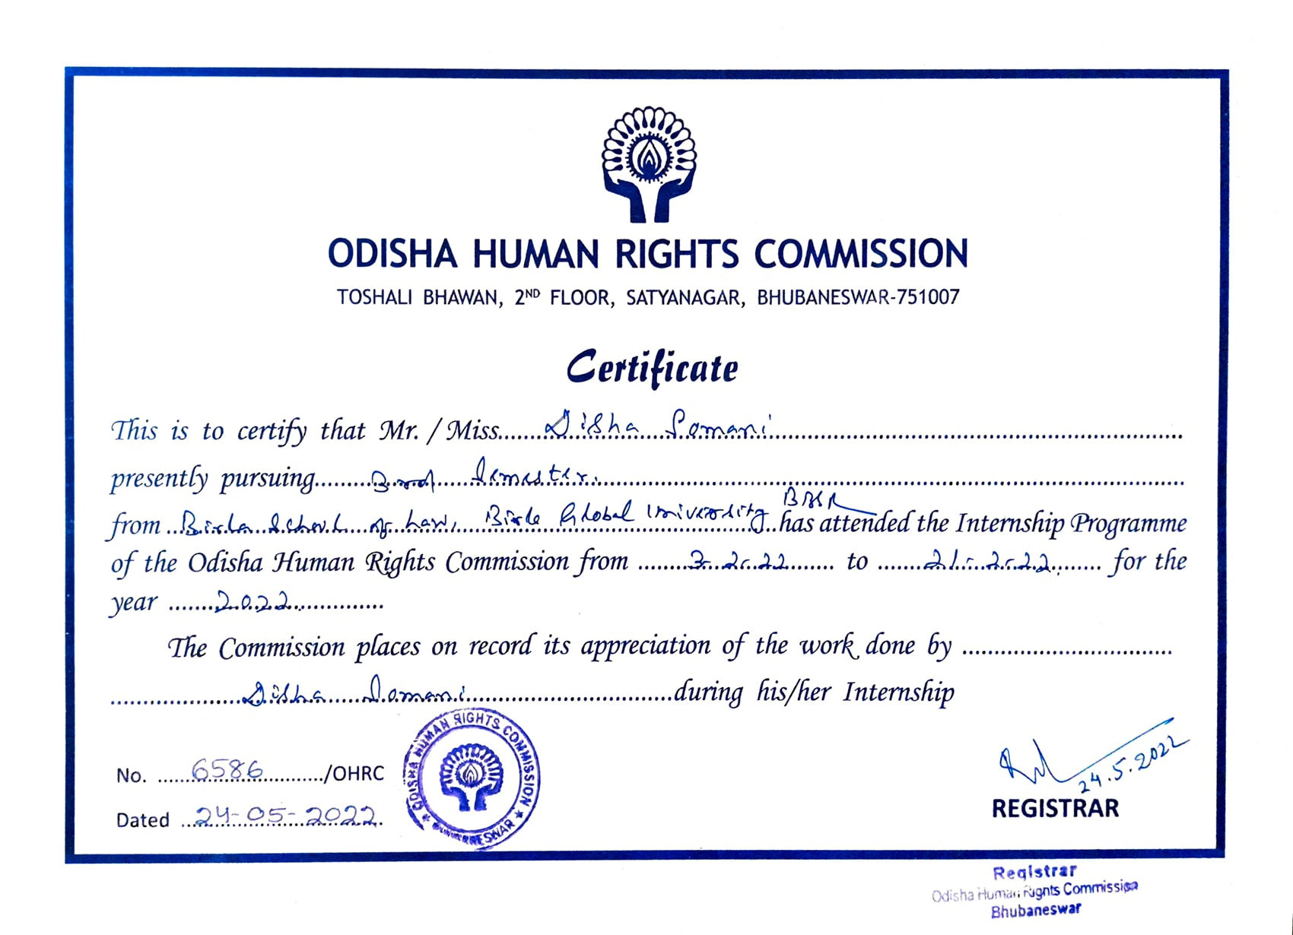
Here in I attach my OHRC certificate

.

