CURRICULUM VITAE
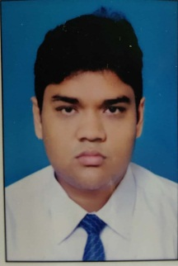
NAME: SOUMICK MALLICK

FATHER’S NAME: RANAJIT MALLICK

PER. ADDRESS: VILL-VIVEKANANDA NAGAR
INFRONT ANUKUL ASHRAM
PO & PS PANDUA
DIST HOOGHLY
PIN 712149
WB

CONTACT NO: +91-8967245575

DOB: 29TH AUGUST 1999

NATIONALITY: INDIAN

RELIGION: HINDU

CASTE: SC

SEX: MALE

LANG. KNOWN: BENGALI ENGLISH HINDI

EMAIL ID: soumickmallickanoy@gmail.com anoysoumickmallick@gmail.com

ADHAR CARD NO: 5196-3365-9022

PAN CARD NO: FYHPM0644A

VOTER CARD NO: RVU2390722

EDUCATIONAL
QUALIFICAYION:

EXAM | BOARD/UNIVERSITY | YEAR OF PASSING | % OF MARKS
MADHYAMIK | WBBSE | 2014 | 67.85
H.S. | WBCHSE | 2016 | 65.60
BSC (BIO-CHEMISTRY HONS) | BURDWAN UNIVERSITY | 2020 | 55.60

EXPERIENCE: APPLYING AS FRSHER

DATE:……………………………..
PLACE: ………………………….. SIGNATURE:

