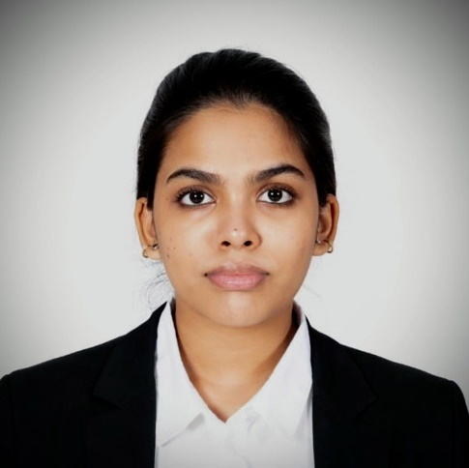
KONTHETI SUBRAMANYA SAI LAKSHMI ANUHYA
21010126039@symlaw.ac.in
Call +917028881045
WhatsApp- +919347433012

ACADEMIC QUALIFICATIONS
- 2021- Symbiosis Law School, Pune
Semester 1- 8.25
Semester 2- 7.52
Semester 3- 7.20
Semester 4- 7.05
- 2020-Sri Gayatri Junior college (Telangana State Board)
89.9%
- 2018- JSS International School, Dubai (ICSE)
81%
POSTION OF RESPONSIBILITY
- Member of Student Advisory Board (SAB)- PRM Core Member (2023-2024)
- Head of the Debate and MUN club (2018-2019)
- Active Member of the Environmental Club (2017-2020)
- Member of F1 for Schools (2019-2020)
Internships and VOLENTEERING ACTIVITES
- AECOM Private Limited; Contracts, Company Laws and Intellectual Property Rights; Delhi (July 2023)
- Interned with Lexpeeps, Daily Legal Analysis (January 2023)
- Interned with the Law Reporter, Dubai (August 2022)
- Did content writing internship with Jurist Centre (July 2022)
- Interned with Muskurahat Foundation (February 2022)
- Member of beach cleanup drive and clean up UAE (June 2019)
- Member of Yanni Animal Welfare, UAE (February 2019)
CO-CURRURCULAR AND EXTRA-CURRCULAR
- Perusing diploma in International Business Laws and Corporate Laws in India (2022-23)
- Participated International Commercial Arbitration Moot Championship (ICAMC) Researcher- Best Respondent Memorial and 2nd Runners Up (2023)
- Took part in Symbhav PRM Committee as photographer (2022)
- Won inter and intra university photography Competitions (2022)
- Won best delegate and honorary mention awards in various MUNs (Harvard Model United Nations (2019), AUDMUN (2019), WIMUN FUNA (2018), JIMUN (2018))
AREA OF INTEREST
- Corporate law
- Intellectual Property Rights
- International Law
- Family Law
TECHNICAL SKILLS
- Software: MS Office, Canva, Photoshop, LATEX
- Database: Manupatra, SCC Online, West Law Asia, HeinOnline, Jstor
- Languages: English, Hindi, Telugu
- Soft Skills: Leadership, Public Speaking, Event Management, Writing, Teamwork

