Curriculum Vitae
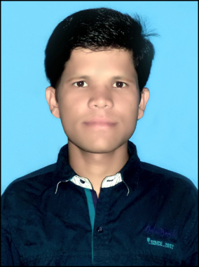
HARIRAM SAHU
ITI, Electrician

Phone: +91 82981 09314 (Mob.)
E-mail: hariramsahu131@gmail.com

CAREER OBJECTIVE

To work in a reputed organisation where I can utilise my technical knowledge in the domain resulting in tangible output for the organisation along with learning new things for continuous personal and professional improvements.

ACADEMIC QUALIFICATION

Examination Passed | School/ College | Board/  University | Year of Passing | Percentage
ITI | Rairangpur Industrial cum Production Centre | S.C.T.E. & V.T.  Odisha,Bhubaneswar | 2013 | 89.14%
B.A. | K.S. College Seraikela, Seraikela | Kolhan University | 2019 | 59.9%
Intermediate (I.A.) | Chhotanagpur College, Hensal | J.A.C Ranchi | 2016 | 51.6%
Matric (10th) | S. S. High School, Rajnagar | J.A.C Ranchi | 2009 | 51.8%

WORK EXPERIENCE

- Electrician at Pellet plant, Tata steel limited Jamshedpur
(2Feb 2017 to 17 Jan 2018)
- Electrician at Graphene Development Centre, Tata Steel, Jamshedpur
(January 2018- present, 5 Years 8 Months)

Job profile:
- I am responsible for the preventive (shutdown) and breakdown maintenance of electrical control and power panels of various laboratory equipment and machinery such as graphene reactors, vacuum ovens, CHNS, Bar sonicator etc.
- I also take upon high tension (HT) maintenance which includes MMCB, VCB maintenance.
- I also undertake cable (80 sq mm to 630 sq mm) laying works.
- In control panel maintenance, I am familiar with PLC, SMPS, Contactor, CP, small relay board maintenance work.

- Electrician at JMT Forging Auto Limited, Jamshedpur
(November 2013- February 2017, 3 Years 3 Months)

Job profile:
- In JMT forging, I had performed preventive and breakdown maintenance of the electrical control and power maintenance of various machineries such as CNC, Forging, Welding (440 V) and BMC machines.
- I also had the responsibility of electrical as well as mechanical maintenance of the Lathe machine.
- I am also familiar with short blasting and ISO maintenance.

VOCATIONAL TRAINING

- 3-month Electrical maintenance project at L&T, Kanchipuram, Chennai.
In this vocational training I learned about earth pit checking and solar resistance value checking.

SKILLS

Computer Skills: MS Office and Internet.
Language Proficiency: Hindi, Odia, English (Read, Write, Speak)
Bengali (Read, Speak)

AWARDS AND ACHIEVEMENTS

- Received Platinum category competency certification from Tata Steel.
- Completed 10 Km run-a-thon (organised by Tata Steel) in 32 min 6 second (8th position)

STRENGTH

- Good analytical and problem solving skills
- Good communication skills
- Willingness to learn
- Positive attitude and ability to work in team

HOBBIES AND INTEREST

Running, Football, Music, Making new friends

PERSONAL INFORMATION

Father’s Name: Gour Sahu
Date of Birth: 07/Feb/1994
Gender: Male
Marital Status: Married
Nationality: Indian
Permanent Address: Village- Gopinathpur, P.O- Govindpur,
P.S.- Rajnagar, Dist- Seraikela-Kharsawan, 831002, Jharkhand

DECLARATION

I hereby declare that the above information is true and correct to the best of my knowledge.

Date: 24/08/2023
Place: Jamshedpur ( Hariram Sahu)

