C.V.

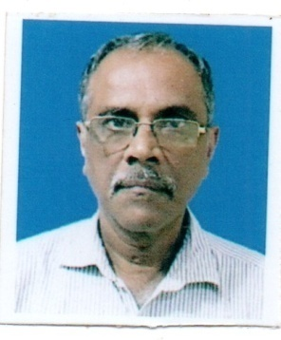

- Name : RANJAN KUMAR BANDYOPADHYAY

- Address and Contact Nos. : Flat No. B-2/7, Purba Abasan,
25, Rai Charan Ghosh Lane,
Picnic Garden, P.O. – Tiljala,
Kolkata – 700 039.
Phone Nos. 7278590184 and 9836395386
Whatsapp: 9836395386
Landline: 033-23431369
e-mail ID:
bandyopadhyay61ranjan@gmail.com
bandyopadhyay_ranjan@rediffmail.com

- Date of Birth : 01/07/1957

- Educational Qualifications : B.A. (Hon) in Economics and LLB
(both passed from University of Calcutta)

- Working experience
:

Sl.  No. | Name of organisation /Department | Period of service |  | Post held | Remarks
 |  | From | To
1. | Central Telegraph Office, Calcutta  (under administrative control of General Manager, Telecommunications, West Bengal Circle, Indian Posts & Telegraphs Department) | 12/09/1980 | 21/03/1981 | Stenographer  (Regular) | Resigned for joining National Cooperative Development Corporation.
2. | National Cooperative Development Corporation (A Statutory body under Department of Agriculture and Cooperation, Ministry of Agriculture, Cooperation and Farmers’ Welfare, Government of India. presently Ministry of Cooperation, Government of India). | 23/03/1981 | 30/06/2017  (Date of superannuation on attaining age of 60 years) | Stenographer/ Personal Assistant.  Subsequently promoted as  Senior Personal Assistant.  Subsequently promoted as Private Secretary.  Subsequently promoted as Senior Private Secretary. | ------
3. | West Bengal State Agricultural Marketing Board (A Statutory body under Department of Agricultural Marketing, Government of West Bengal). | 27/12/2017 | 26/06/2022  (Contract expired on attaining age of 65 years on 01/07/2022. Yet, I was allowed to work till 28/07/2022) | Personal Assistant  (Worked with Chief Executive Officer of the Board who is an IAS officer) | Service was on Post-retirement re-engagement on contractual basis.
4. | M/s. Mulla & Co.  Advocates,  86-B, Fazlul Huq Sarani,  Kolkata – 700 017 | 20/09/2023 | Continuing | Liaising Executive cum Administrative personnel | -----

Note: After retirement from Government service, I have been enrolled as an Advocate by Bar Council of West Bengal on 14/07/2023 my Enrolment No. being F/450/2023. My present job at M/s. Mulla & Co. include (a) liaising with Banks for collection of legal documents as per check list before initiating proceedings in DRT and City courts (Money suit) (b) preparation / drafting of O.A. applications, S.A. objections (in case of DRT) and Money suit (for Civil Courts), visiting High Court for Caveat filing and attending DRT-I, DRT-II and DRT-III in Kolkata as and when required. My employer deals mainly with legal suits against defaulting borrowers relating to bank loan.

