Mr.KANCHAN CHAKRABORTY 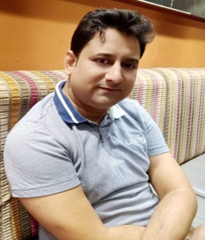
Vill- Sodepur P.O.- Sodepur
Dist- North 24 Parganas West Bengal, India 09830391363
E-Mail: kanchan_102@rediffmail.com

___ _ _ _ _ _ _ _ _ _ _ _ _ _ _ _ _ _ _ _ __ _ _

Objective:-

Being a hard working and sincere person I want perseverance and honesty. As I love
To meet new challenges, I would like to work with an organization whenever I can Accept chance to grow professionally using full potential.

Working Experience:-

Current worked with Astha Sanitation Marketing Pvt.Ltd (2010 to Continue…)

Designation: Accountant (Banking) cum Cashier
Responsibility of duties is all banking works like REGS/NEFT Payment All Online Payment, BRS, & All Entry In Tally Software. GST Return (GSTR 1 & 3B).

Had worked with “ISKCON MAYAPUR” (2008 to 2010)

Designation: Treasury Accountant (Banking) & Assist with CA to Finalization of Balance Sheet and Audit

√ Had worked with “MEGAMART VYAPAAR Pvt.Ltd” (2003 to 2008)

√ Designation: Accountant cum Cashier Responsibility: Maintenance Accounts

√ Had worked with “KARUNA FINANCIAL SERVICES Pvt.Ltd” (2001 to 2003)

√ Designation: Accounts Assistant

√ Had worked with “R CHOWDHURY & CO (CA FARM)” (2000 to 2001)

√ Designation: Accountant

Educational Qualification:-

Graduation: Commerce from Calcutta University Schooling: H.S.’05 from W.B.C.H.S.E.

Computer Knowledge:-

Well versed with computer working Knowledge & handling Office (Word, Excel, Internet) & TALLY

Other Qualification:-

The “ Industrial Accountant “ course from ICA Training Institute.Sovabazar Branch
Which included PROFESSIONAL TAX

Language Known:-

Speak- Bengali English and Hindi.
Write- Bengali English
Read- Bengali English and Hindi.

Personal Details:-

Father’s Name :- Narayan Chandra Chakraborty

Date of Birth :-23rd September, 1978

Subject of Interest :- Accountancy, Cashier

Hobbies :- Listening Music, Travelling.

Sex :- Male

Declaration:-

I do here by declare that the information furnished above is true to the best of my knowledge and belief.

Date:______ __ ……………………
(Kanchan Chakraborty)

