BIO-DATA

- N a m e : DEBASISH BASU

- Father’s Name : Sri Sankar Lal Basu

- Address : 30, East End Park
1st Road,
PO – Kalikapur, PS – Garfa,
Kolkata – 700 099

- Date of Birth : 17th day of November, 1967

- Educational Qualifications : B. Com. (Pass) in 1984 from the University of Calcutta.

- Speed in Shorthand & : 100/45 W.P.M.
Typewriting

- Experience : Worked as Steno Secretary, Assistant Manager with an
Engineering Company since July, 1997 till January, 2024.

Job Description
- Take dictation in shorthand from departmental heads
- Handle correspondence independently
- Send payment reminders
- Send order reminders
- Prepare offers for clients
- Prepare Delivery Orders and Dispatch Documents
- Prepare various invoices, Statements, Banking correspondence related to Accounts
- Prepare vendor registrations
- Prepare and send introductory letters to new clients
- Maintain and update filing systems
- Maintain Job numbers after getting orders
- Handle confidential matters/information of the Company

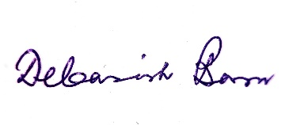

(DEBASISH BASU)
Mob. No.6290268089
E-Mail ID debasishbasu833@gmail.com

