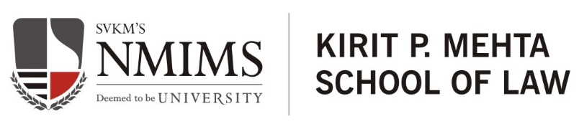
Vikrant
B.B.A. LL.B. 2019-24
Email ID: Singravikrant@gmail.com/ Contact No.: 9321163914
D.O.B.: _24-03-2001
ACADEMICS
Qualification | Name of the Institute | Board/ University | Year of Passing | Percentage/ CGPA
B.B.A LL.B. (Hons.) | NMIMS Kirit P. Mehta School of Law | NMIMS University | 2019 to Present | 3.3
XII | Shyam Memorial Sr. Sec. School | HBSC | 2018 | 72
X | Little Angels Sr. Sec. School | CBSE | 2016 | 77

INTERNSHIPS
Name of the Firm/ Organization | Internship duration | Year
R.K Dewan & Co.  - Assisted in filing Letter to registry, RTI, TM-M and Design Application.  - Assisted in drafting of Reply to examination report, Evidence in support of Opposition under rule 45 and 47.  - Assisted in drafting of Co- existence and settlement agreement. | October to December | 2023
G.S. Rijhwani  - Assisted in drafting evidence in support of opposition under rule 47 of trademark rules 2017.  - Assisted in drafting evidence in support of Application under rule 46 trademark rules 2017.  - Assisted in drafting Notice of Opposition.  - Assisted in drafting Counter Statement. | July to September | 2023
Maheshwari & Co.  - Assisted in drafting replies to examination reports.  - Assisted in drafting of plaint.  - Assisted in drafting Notices.  - Research on companies act,2013. | June | 2023
Solomon &amp; Co.  - Assisted in drafting of Conveyance deed, Power of attorney, Sale deed.  - Researched on the intersection of the IBC and IPR.  - Researched on trademark and metaverse with respect to India.  - Carried out research on the rights of influencer. | February | 2023
Khurana & Khurana, Pune  - Drafted trademark search report  - Drafted reply to examination report and carried out trademark search.  - Drafted, legal notice and legal opinion related to music licensing.  - Researched on licensing permission in case of musical toys trademark and copyright case laws. | October &December | 2022
Oil & Natural Gas Corporation, Mumbai  - Researched on NI Act.  - Researched on Debt recovery issues.  - Researched on marine laws.  - Assisted in drafting of Statement of Claims | June | 2022
Chamber of Ajiit K. Soni, Advocate, Rohini court, New Delhi  - Read case files and research on cases related to negotiable Instrument Act, 1881, debt recovery, maintenance.  - Observed physical Rohini court proceeding.  - Assisted in drafting of sale purchase agreement, Leave and license agreement, residential lease agreement, commercial lease agreement. | December | 2021
Public Concern of Government Trust, Mumbai  - Attended practical RTI sessions and imbibed hands-on Experience.  - Designed infographics for social media.  - Researched on various legal issues. | September & October | 2020

ACHIEVEMENTS/ CO & EXTRA CURRICULAR ACTIVITIES
- Completed IP Asset Management Course organized by Maharashtra National Law University, Mumbai.
- Participated in Intellectual Property awareness seminar organized by Rajiv Gandhi National Institute of Intellectual Property Management, Government of India.
- Participated in the Indian Mediation Week ADR Summit, recognized by Ministry of Law and Justice, Government of India and successfully completed the Sama ADR Case Management Workshop.
- Participated in Amity National Moot Court Competition 2021.
- Participated in 4th National Mediation Competition 2021 Organized by the Society for Young Advocated and Researchers (SYAR).
- Participated in Intra Mediation 2021 organized by NMIMS School of Law
- Participated in the School of Law Model United Nation 2020 organized by NMIMS School of Law
PUBLICATIONS
    - Paper tiled ‘increasing domestic violence cases during lockdown’ published in paradise volume of center of legal research and studies.
    - Blog titled “Legal Implication of LIBOR transaction in Banking Industry” published at Khurana & Khurana.
    - ‘Evaluating the impacts of the law on divorce: Has it increased the cases of divorce or reduced them’ published in Bhumika Trust.
    - ‘Reviewing the major changes of family law in the last 50 years’ published in Bhumika Trust.

LANGUAGES SPOKEN
- English – Proficient
- Hindi – Fluent

