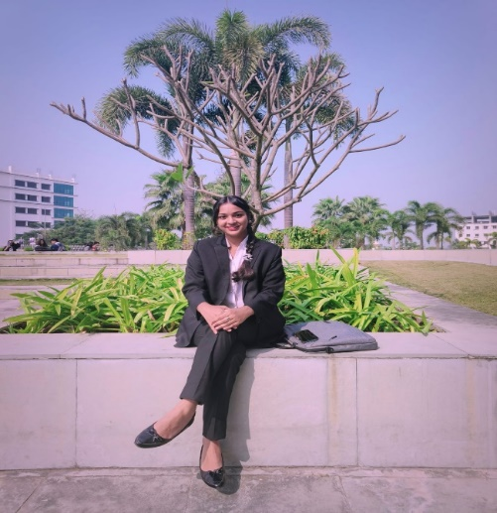
Name: Indrani Ghoshal.
Permanent Address:
Vill+P.O- Madanpur
NADIA, Dist.- West Bengal
Pin No- 741245
Contact No.: 9875580897
Email: ghoshal.indrani123@gmail.com

CAREER OBJECTIVE

Looking For an internship program in a reputed legal organization where I could improve my law and legal policies related Skills, Knowledge and where my potential will be maximized while working with perseverance and the most active commitment to the association.

ACADEMIC BACKGROUND

Year(s) | Degree / Diploma / Certificate | Board / University | College / Institute / University | Percentage / CGPA
2018-2019 | Madhyamik | W.B.B.S. E | Madanpur K. A. Vidyalaya Girls | 85.03%
2020-2021 | Higher Secondary (Science) | W.B.C.H.S. E | Madanpur High School (H.S) | 87.00%
2021-2026 | B.A., LL. B (Hons) | Amity Law School, Kolkata | Amity University, Kolkata | 8.38 CGPA (As per the 4th semester)

INTERNSHIPS

Chambers of Adv. Jeevan Prakash, AOR, Supreme Court of India (Remote) February 2022 (4 weeks)
- Advising Moot Clients
- Making Videos on Legal Topics
- Experiencing Client Counseling
- Finding Legal Solutions

Chambers of Adv. Naba Kumar Das, Kolkata High Court (Physical) July 2022 (4 weeks)
- Engaged in Client meetings and contributed to group discussions concerning the multifaceted legal landscape of the nation.
- Handed cases pertaining to labour, civil and criminal laws.
- Drafted legal Notices, anticipatory bails, and quashing petitions.

Chambers of Adv. Tonmoy Bhattacharjee, Kalyani, Sub- Divisional Court (Physical) July 2023 (4 weeks)
- Drafted legal Notice and petition.
- Worked on certain criminal matters such as Divorce, Rape, Theft, Maintenance of wife and parents, Bail, and Bail Bond.
- Conducted extensive research on various act such as Indian Evidence Act, Indian Penal Coad, and Criminal Procedure code.

MOOT COURT AND CO-CURRICULAR ACTIVITIES

- Participated in MUN held by Amity Law School, Kolkata and received Special Appreciation.

SKILLS

- Language: English (Fluent), Bengali (Fluent), Hindi (Advanced), French (Intermediate),
- Technical Skills: Microsoft Office Essentials (MS Word, MS Excel, MS PowerPoint), Canva.

PERSONAL DETAILS

Date of Birth – 08/01/2024

Gender - Female

Father’s Name – Bibhu Nath Ghoshal.

Mother’s Name - Priti Ghoshal.

I, Indrani Ghoshal student at Amity University Kolkata, hereby solemnly affirm and declare that what is stated is true to the best of my knowledge.

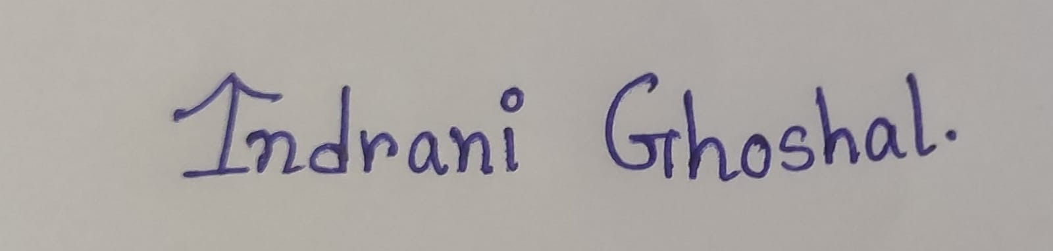
Signature

