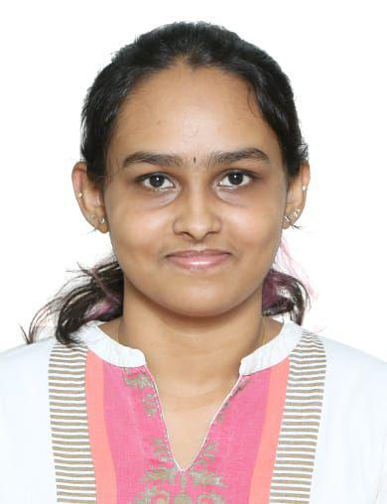 Ms KRISHNA MUKUNDAN

PROFILE  I am a hardworking, enthusiastic student. I am very eager to do research and do analytical skills. Possesses excellent verbal and written communication skills honed through the number of competitions I have participated in.  contact:  PHONE: +91 9447330644  EMAIL: krishnamukundan.student@slsnagpur.edu.in  ADDRESS:  Vrindavanam, Near Emke Garden,  Kuttur PO, Thrissur  ADDITIONAL QUALIFICATIONS:  School vice captain in 11th grade  Voluntary Work/Positions of Responsibility:  - Volunteer in child help foundation  languages KNOWN:  English  Hindi  Malayalam |  | EDUCATION:  Pursuing B.A. LL.B. (2021-2026), Sem VI Symbiosis Law School, Nagpur – Last Sem CGPA – 6.64  INTERNSHIPS UNDERTAKEN:  Jayanth Pattanshetty Associates From 12th May to 07th June  Thrissur District court from 20th June to 07th July  Thrissur District Court From 5th Dec to 2nd Jan  Online internship at Hamari Pehchan NGO 2022  Internship at Child Help Foundation, Kochi NGO 2022  At Jayanth Pattanshetty Associates, I was tasked with the responsibility of researching case laws based on property law and disputes.  At Thrissur District Court I was tasked with the responsibility of visiting courts and observing cases.  CO-Curricular participation:  - Participated in Intra Parliamentary Debate 2021  - Participated in Intra Mediation-Arbitration Competition 2022  - Participated in Intra Moot court Competition 2023  - Participated in Tamil Nadu National Law University, Moot court Competition 2024  EXTRA-Curricular participation:  - Participated in Annual College fest “SYMPLYFY.”  - Courtroom Master in 2nd National Med-Arb Competition  - Volunteer in Child Help Foundation for one month.

