5, Shyamananda Road

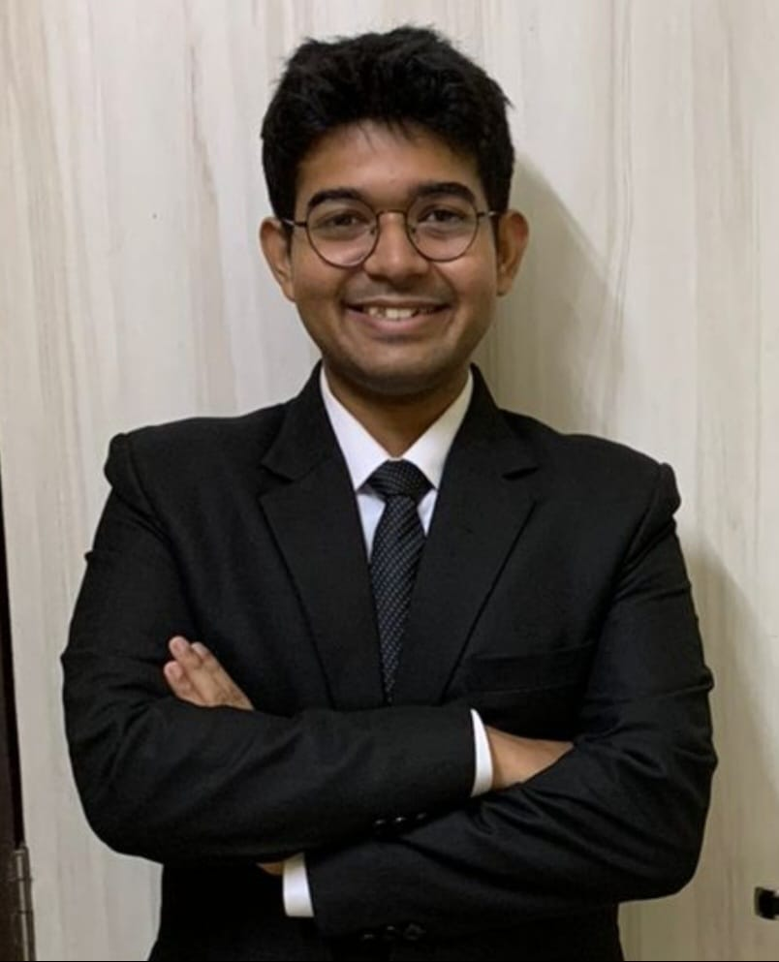

Kolkata- 700025

9836231551

[shirshobanerjee14@gmail.com](mailto:shirshobanerjee14@gmail.com)

SHIRSHO BANERJEE

OBJECTIVE To secure a challenging position where I can effectively contribute my skills as a legal professional, possessing competent skills and make professional growth while being resourceful, diligent, innovative and flexible.

# EXPERIENCE TRAINEE, S.MAJUMDAR & CO.

February, 2024 - Present

* Prepared a detailed probable list of arguments against the judgement of Shree Ganesh Besan Milll and Others Vs. Ganesh Grains Limited and Another.
* Provided relevant judgements related to proprietorship being granted to numerical based trademarks,
* Provided relevant judgements related to god trademark.
* Provided relevant judgements for false user claim and in relation to the “Paperkraft” & “PaperKart” matter.
* Made a Short List of Dates, Documentation List along with a probable argument note on the “TAAZA” matter.
* Drafted an Evidence in Support of Opposition in the “Morning Raga” Matter.
* Drafted an Evidence in Support of Opposition in the “PAPERKAITE” Matter.
* Drafted a Letter Template for Unauthorized Trademark usage – Withdrawal of TM App.
* Drafted a proposed well-known application for “LINC LIMITED”.
* Drafted a proposed well-known application for “EXIDE LIMITED”
* Drafted dealer affidavits for the proposed well-known application of EXIDE.
* Drafted a response to the affidavit filed by the applicant’s advocate in the “ESSENCIA” matter.
* Conducted exhaustive public searches for the different trademarks of clients.
* Made a detailed PPT under the titles “AI & IPR – Unravelling the Intricacies”, “Signs of the Times – Trademark Cases unveiled”, and “Patent Law Panorama – A review of Key cases” along with copy of all discussed judgements.

# LEGAL INTERN, S.S. RANA & CO.

August, 2023

* Researched on the Digital Personal Data Protection Act, 2023 in consonance with child’s right to privacy.
* Assisted in finding issues with Online gaming taxation for children in India.
* Made an exhaustive research note on relevant judgements related to intermediary involvement in protection of right to privacy of online platform users.
* Drafted a detailed research note on amendments brought to the Patent Act, 1970 by way of the Jan Vishwas Act, 2023
* Prepared a compendium of cases on anti-counterfeiting in India through e-commerce platforms.
* Drafted an article on the significance of India’s G20 presidency for the firm.

# LEGAL INTERN, S.MAJUMDAR & CO.

July, 2023

* Drafted a list of probable arguments for a trademark rectification application related to Le Shark matter.
* Making necessary changes to an author’s agreement with Ananda Publishers upholding the Author’s rights to copyright.
* Making an exhaustive research note along with providing essential judgements on Sec. 60 of the Copyright Act.
* Drafted a case synopsis along with a list of suggested arguments for the TOEFL matter.
* Assisted in finding relevant trademarks by way of electronic search for Invicta Watch Company and Invicta Spa.
* Drafted a comprehensive research note on the topic “Counterfeiting in the context of e-commerce”.
* Drafted Newsletters for the firm in relation to latest IPR cases across India.

# LEGAL INTERN, CHAMBERS OF HON’BLE JUSTICE SABYASACHI BHATTACHARYYA

August, 2022

* Worked on when investigation by the CBI can be conducted.
* Worked on matters of testamentary and intestate jurisdiction cases including the Birla testamentary suit which focused on different laws like the Hindu Succession Act followed by the Companies Act.
* Worked on proof – reading orders and making convenience n notes for multifarious cases.

# LEGAL INTERN, CHAMBERS OF THE LEARNED ADVOCATE GENERAL, WEST BENGAL

# – MR. S.N MOOKHERJEE

July,2022

* Worked on the vires of the Duare Ration Scheme implemented by the Gov. of WB,
* Worked on applicability of deed of release or deed of conveyance in a Benaami property under the Transfer of Property Act, 1882 with specific reference to The Prohibition of Benami Property Transactions Act, 1988.
* Worked on vires of the Gorkhaland Territorial Administration Act, 2011.
* Worked on PIL matters in relation to police protection/inaction, locus standi with respect to political motivation & publicity stunt.
* Worked in the matter of challenge to the Teachers Eligibility Test, 2014 for grant of an additional mark without prior publication to candidates which was heard by a Division Bench of the High Court at Calcutta.
* Worked on the trademark infringement and passing off action in a matter with respect to ITC Ltd.

# LEGAL INTERN, CHAMBER OF MR. KALLOL BASU

July, 2021 – August,2021

* Researched on the proposition “Judicial Review is not an Appeal in disguise”.
* Assisted in drafting the writ petition for Cha Bagan Mazdoor Union.
* Drafted a comprehensive note on definitions of Fee, Tax, Levy & Cess.
* Assisted in drafting the writ petition for the Habra Petrol Pump case.
* Drafted the stay application for the Sergeant Co-operative Housing case.

# Drafted a note on non-enforceability of guidelines established under the Essential Commodities Act, 1955

# LEGAL INTERN, CHAMBER OF LATE HON’BLE JUSTICE PROTIK PROKASH BANERJI

December,2019 – January,2020

* Analyzed Briefs
* Made reports

EDUCATION **AMITY LAW SCHOOL, KOLKATA**

**B.A L.L.B (H)** GPA- 8.81

I have been studying law for three years now and I have had my research work get recognized widely. I also happen to have won a handful of moot court competitions representing my university. Needless to mention, I try to be active in the field of extra-curricular activities in the form of:-

* President, Amity University, Kolkata Debate Club
* Senior Student Volunteer, Legal Aid Camp, Amity Law School, Kolkata
* Active-member, ADR Committee, Amity Law School, Kolkata
* Former Editor-in-Chief, Indian Corporate Law Review, Amity Law School, Kolkata

AWARDS AND ACHIEVEMENTS

Secured 2nd position in the NMIMS National Moot Cout Competition Secured 1st position in the National Moot Competition by Nyayshastram

Secured “Best Idea” in the Alternate Dispute Resolution conference by Rotary Club- S. Kol Semi-finalist in Client Counselling Competition organized by LEX MACULA

ADDITIONAL COURSES

Qualified the General Course on Intellectual Property from Lawctopus Qualified the General Course on Contract Drafting from Lawctopus Qualified the General Course on Corporate Law from Lawctopus

Qualified the Course on International Child’s Rights from Harvard University via EdX

SKILLS & ABILITIES Advanced in Legal Research, Client Relationship, Written English Proficiency, Spoken English Proficiency, Online Teaching, ,

Intermediate in MS- WORD, MS- EXCEL, MS- POWERPOINT, Creative Writing, Copywriting, Spoken German Proficiency, Teaching

LEADERSHIP PRESIDENT AT AMITY UNIVERSITY, KOLKATA – DEBATE CLUB

ACTIVE-MEMBER, ROTARACT CLUB- SOUTH KOLKATA, KOLKATA, INDIA ACTIVE-MEMBER, HELPAGE, KOLKATA, INDIA

2 | P a g e