 | 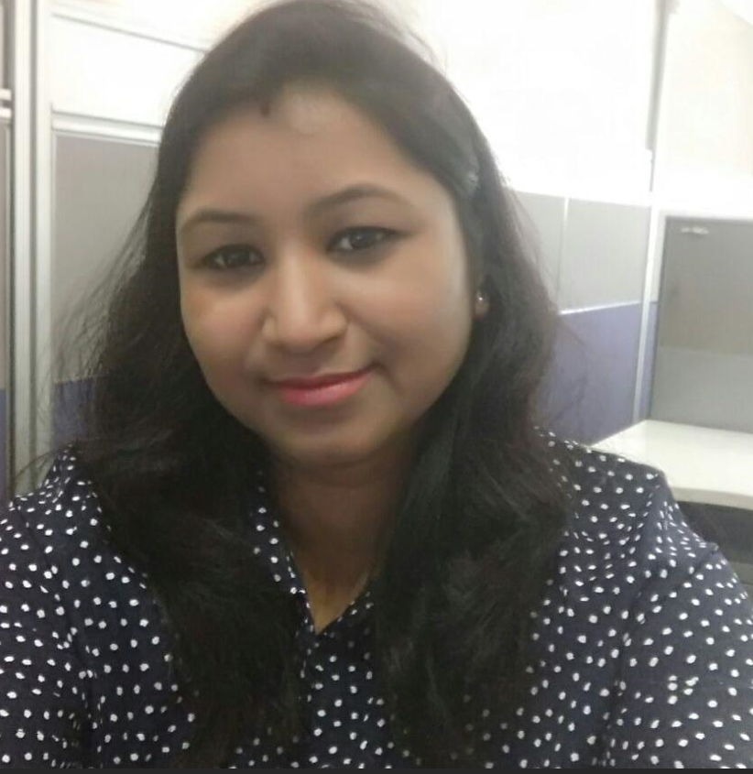 |  | Sarvani Patnaik  IP Lead
 | Profile  Seeking a dynamic role where I can leverage my expertise in IP operations to drive impactful results, while continuously expanding my skills and contributing to organizational success.  Contact  PHONE:  +91 - 9999502204  EMAIL:  sarvani.patnaik@gmail.com  KEY SKILLS AND CHARACTERISTICS  Persuasive Communication and Interpersonal Finesse  Strategic Time Management and Astute Prioritization  Profound Analytical Acumen and Effective Problem-Solving Proficiency  Proven Leadership Competence and Collaborative Aptitude  Proficiency in MS Office Suite and Database Management Systems |  | WORK EXPERIENCE – 14 Years  Clarivate – IP Lead – February 2019 - Present  - Independently manage high-profile client projects and deliverables  - Proactively identify and implement process improvements to enhance operational efficiency.  - Conduct comprehensive data analysis to ensure accuracy and integrity of client databases.  - Collaborate with cross-functional teams to optimize workflow and deliver exceptional service.  - Portfolio Management  - Providing training as and when required  - Recognized for outstanding performance and dedication to quality standards.  EDUCATION  Post Graduation Diploma in Biotechnology  KK (Autonomous) College, Berhampur University, Orissa (2003) - First Division  Bachelor of Science (B.Sc) in Botany (Honors)  Utkal University, Orissa (2002) - First Division  Professional Qualifications:  - Post Graduate Diploma in Biotechnology, Berhampur University, Orissa (2003) - First Division  - Diploma in Computer Application, OEIT (Council of Research and Training)  Certifications:  - Certified IPlegalED Paralegal  - WIPO Certification Course (basics)  Awards, Honors & Accomplishments  - Rastrapati Purashkar in Scouts & Guides (2000)  - Rajyapuraskar in Scouts & Guides (1999)  - Elected Member of Orissa Contingent in Scouts & Guides for 3rd SAARC / 13th National Jamboree (1998)  - First Rank in Elocution Competition (Scouts & Guides, 1997)  - Participant in 4th National Open Rally (Scouts & Guides, 1996)

Personal Information:
Marital Status: Married
Date of Birth: 15th June 192
Hometown: ODISHA
Languages Known:
Oriya, Hindi, English and Telugu
Hobbies: Watching TV, Listening Music

