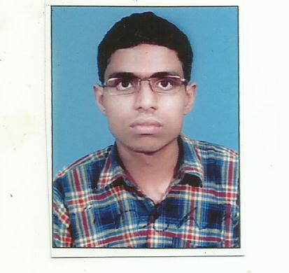

NAME-DEBANIK ROY
Flat no-1B,Daffodil blooms,F/F12 Hatiara road,po-Jyangra,pin-700059
Contact: 9674264323; E-mail: debaec@gmail.com
OBJECTIVE
Seeking a challenging position in a reputed organization which provides opportunities for professional growth and advancement, and utilize the experience acquired in becoming a valuable team member in the field of Human resources in theFMCG,CONSUTLTANCY,TRAINING,COORPORATE HR,AUTOMOBILE industry
PROFILE

- Academically astute individual offering in-depth academic knowledge, practical project exposure and an effective analytical ability augmenting a highly creative and expressive mind.
- Self motivated, hard working and goal-oriented with a high degree of flexibility, creativity, resourcefulness, commitment and optimism
- Result oriented individual with strong analytical and interpersonal skills and a quick learner with high levels of adaptability and ability to take initiative.
- Good communication skills, verbal as well as written coupled with exceptional presentation skills.
- An effective team player with exceptional planning and execution skills coupled with a systematic approach and quick adaptability
EDUCATIONAL CREDENTIALS

Full time Programme in National Economic Planning and Entrepreneurship (Leading to Masters in Business Administration)(HUMAN RESOURCE SPECILIAZATION)(MGU MEGHALAYA)

Name of Graduation degree-B.TECH(ELECTRONICS AND INSTRUMENTATION)(2009)
Name of the Institute/university-WBUT;

Class XII-2005
Name of School/board-WBCHSE;
Class X-2003
Name of School/board-WBBSE;

Technical Proficiency
Windows 97/2000/XP, MS Office, Internet Applications

Summer Internships
Title | NCDP
Company | Coal India Limited.
Role | Sales and marketing
Duration | 6 Weeks
Synopsis | Research about the New Coal distribution policy of coal Ministry of India.  TITLE-Industrial training in SAIL for 2 months.

Projects Undertaken
Life as a journey(EXCOM),Country Presentation(Brazil),NEP,Adzap,Audio drama,Movie making.hollywood personality.

Work Experience- COMPANY DESIGNATION FROM TO
LIC PDO MAY 2016 MARCH 2017
Job Duties :
- Recruitments of Agents.
- Training Agents for IRDA Exam.
- Procuring Life Insurance Policies through Agents as per given Target.

Extra Curricular Accolades – Diploma in vocal music
Achievements-Gold Medal as coach of college football team.Won 2nd prize in Hindi recitation.
Date of Birth: 01/07/1987
Languages Known: English,Bengali,Hindi
Hobbies: Watching football. reading detective books and Sharatchandra Chattejee books
Permanent Address: Flat no-1B, Daffodil blooms,F/F12 Hatiara road,po-Jyangra,pin-700059 dist-North 24 pgs

