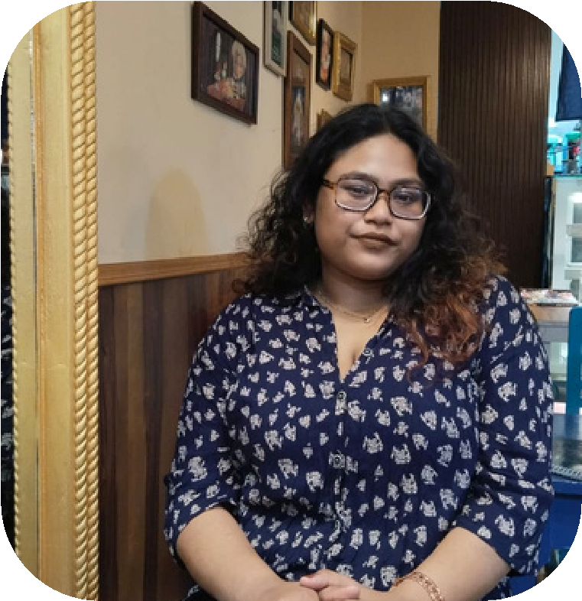

**SENJUTI RAY**

Law Student | Rotaractor

**About Me**

**Professional Experience**

**Positions of Responsibility**

Driven and Ambitious Law student with a knee interest in

Property Law,Contract Law,ADR,IPR and Data Protection.

Active Rotaract member, dedicated to community service and

social impact.With a strong academic background and

provocative approach to learning, I thrived in challenging

environment where i can apply my analytical skills to solve

complex legal issues. Eager to leverage my Legal education and

Rotaract experience to make positive difference in society .

**Skill**

**Languages**

**English**

**Bengali**

**Hindi**

**Education Background**

**University of Calcutta**

***B.A.LLB***

**Secured - 7.98 GPA by the end of 6th Semester**

**Ramkrishna Vivekananda Mission (2020)**

WBCHSE - 85%

**Nivedita Vidyapith**

**(2018)**

***WBBSE - 73%***

**My Contact**

**senjutiray33@gmail.com.com**

**243**

**,R.N. Tagore Road, Sodepur**

**Kolkata -700110**

**+91 9330293658**

**Legal Intern**

•Member of Journal Committee Academic Society of

SNLC(2021- present)

• Secratary Administrative of RCCP-Sahayaam (2022- present)

**Social Media Marketing**

**• Conducted research on case laws, statutes and regulations relevant to on-**

**going cases**

**• Drafted Legal Notice related to Dishonouring of Cheque.**

**• Reviewed and drafted Agreement for Sale and Deeds & Deed of Gifts.**

**• Attended client meetings , court hearing.**

***Adv. Jayshree Saha , High Court of Calcutta***

***& City Civil Court***

***(2023- 2024)***

***Aashman Foundation (2020-2021)***

**Develop and implement social media strategies aligned with business**

**objectives.**

**Analyze performance metrics and adjust strategies according to optimize**

**results**

**Stay compliant with legal and ethical guidelines in social media marketing.**

**Hobbies and Interests**

**Legal Research and Analysis**

**Legal Writing and Advocacy**

**Communication and Interpersonal Skills**

**Volunteer Management**

**Negotiation**

**Microsoft Office**

• Participating in Moot Courts Competition & MUN to

sharpen negotiation and advocacy skills.

• Practicing Yoga regularly for physical and mental well-being.