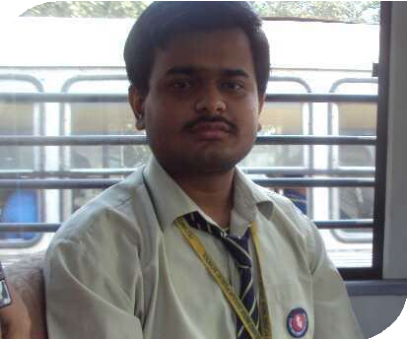

**PRATYUSH SHAW**

**LEGAL INTERNSHIP|**

# OBJECTIVE EDUCATION

I want to explore the the new frontiers of law and distinguish myself from others as well learn the practical skills related to drafting consulting and Advocacy and gain first hand experience of diverse work in an internship

.

# SKILLS

Strong Grip on Copyright Act and

Other IPR Laws

Contract Drafting

Strong Legal Aptitude Good Communication skills

Thinking and problem solving skill

High level of Understanding in Economics

Leadership Ability Interpersonal Skills

## UNIVERSITY/COLLEGE

Department Of Law **C**alcutta **U**niversity (**4TH** year) **CGPA**- 7.5

## CS EXECUTIVE STUDENT (ICSI)

CSEET (Passed 1st attempt 145/200)

## HIGHER SECONDARY (CBSE)

93 Percent Techno India Group Public School Chinsurah

## SENIOR SECONDARY (CBSE)

88 Percent Techno India Group Public School Chinsurah

INTERNSHIPS

FICCI IPR Division

Worked on various IP matters assisting the Joint Director IPR.

JUS CORPUS LAW JOURNAL

Conducted Acedemic Resarch work for the journal.

Legal Vidhya

Research work in law

# ACHIVEMENTS

SEMI FINALIST at 2nd BASANT K SHARMA MEMORIAL

MOOT COMPETITION

QUATER FINALIST AT G 20 YOUTH SUMMIT KOLKATA QUIZ

## SILVER MEDAL IN INTERNATIONAL ENGLISH OLYMPIAD

Class 11th

## CERTIFICATE OF MERIT IN INTERNATIONAL ART AND ESSAY COMPETITION

[Pratushshaw2001@gmail.com](mailto:Pratushshaw2001@gmail.com) 9831155790 [linkedin.com/in/pratyush-shaw-562414224](https://www.linkedin.com/in/pratyush-shaw-562414224)

