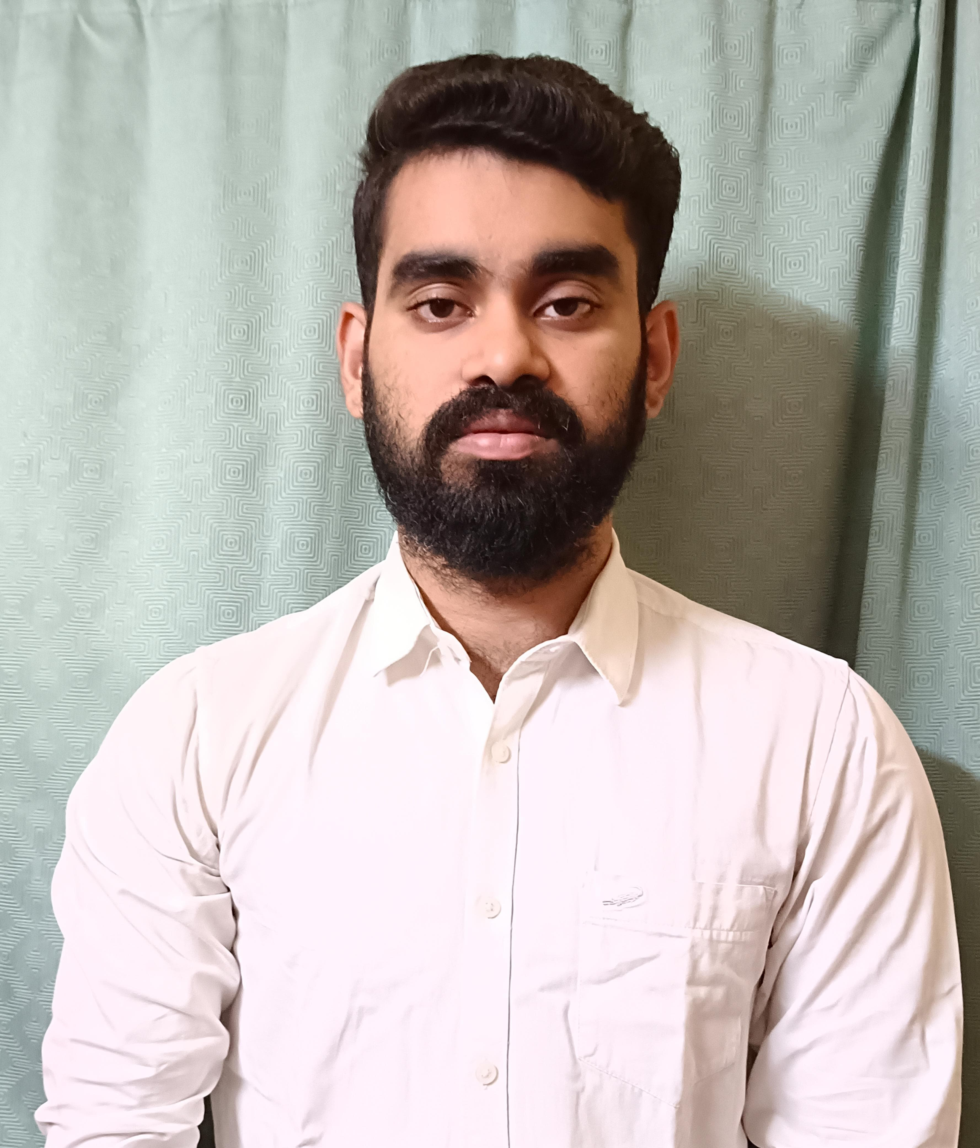 |  | RISHABH LODH
Profile  Hi, I am a Law Graduate from JIS University, Kolkata (convocation pending). I am a passionate learner and looking forward to learning and developing my understanding of the legal system and facets of criminal, civil and corporate law. Towards that direction, I am looking forward to an engagement where I am not only able to gain insights and training but also contribute positively to the team which takes me as I focus towards growing my career in the Legal domain.  CONTACT  PHONE NUMBER:  9038818584  ADDRESS:  64/2 Narasingha Avenue, Dum Dum Nager Bazaar, Kolkata - 700074.  EMAIL ADDRESS:  rishabhlodh@gmail.com  HOBBIES  Hobbies:  - Photography  - Bike Riding |  | EDUCATION  - Passed ICSE (STD 10) 2013.  - Passed ISC (10+2) 2015.  - Completed BBALLB 2019-2024 from JIS UNIVERSITY  - Convocation pending.  WORK EXPERIENCE  - Internship at R&S Associates (Law Firm) for 2 months.  - Internship program at Legal Options law firm for 1 month.  - Internship of 1 month with Adv. Aman Baid (High Court At Calcutta)  SKILLS  - Legal research work.  - Attended & participated in moot court competitions.  - Given seminars on legal topics  * IPR  * Trademark

