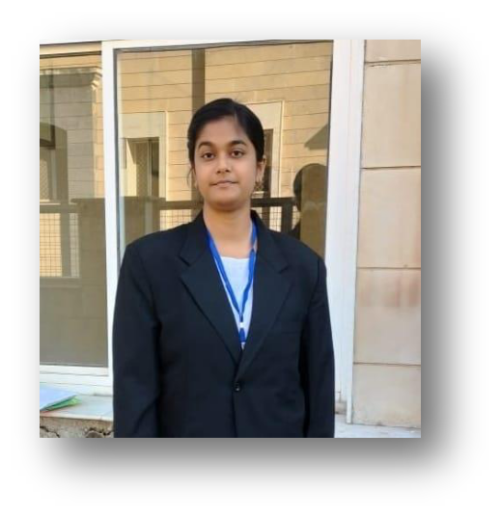

SANSKRITI MISHRA



**D.O.B: -** 09.01.2003

**CONTACT-** 8757910100, 8890900483

**MAIL-** [*mishrasans09@gmail.com*](mailto:mishrasans09@gmail.com)

**COURSE**- B. Com LL.B. 4th YEAR (VII Semester)

**COLLEGE**- Jamnalal Bajaj School of Legal Studies, BANASTHALI VIDYAPITH, RAJASTHAN (304022)

**CAREER OBJECTIVE**

I am a very hardworking and enthusiastic student I wish to secure a responsible position to enhance my skills and knowledge and to gain some new experience. I can assure you that I would devote myself in prosperity of your organization and become an asset for the same.

**COMPUTER SKILLS**

SOFTWARE: MS WORD, MS EXCEL, MS POWER POINT

OPERATING SYSTEM: WINDOWS

**ACADEMIC BACKGROUND**

|  |  |  |  |  |
| --- | --- | --- | --- | --- |
|  | **YEAR** | **INSTITUTE** | **PLACE** | **GRADES** |
|  |  |  |  |  |
| **B. Com LL.B.** | **2022** | **BANASTHALI** | **JAIPUR, RAJASTHAN** | **9.47** |
| **{Upto 7th SEMESTER}** |  | **VIDYAPITH** |  | **CGPA** |
|  |  |  |  |  |
| **CLASS - XII** | **2021** | **SACRED HEART** | **SITAMARHI, BIHAR** | **79.04%** |
|  |  | **SCHOOL** |  |  |
|  |  |  |  |  |
| **CLASS - X** | **2019** | **CENTRAL** | **LUCKNOW, UTTAR** | **95.2%** |
|  |  | **ACADEMY,** | **PRADESH** |  |
|  |  | **AASHIANA** |  |  |
|  |  |  |  |  |

**POSITIONS**

* Pro Bono Associate at the Pro Bono Club of Faculty of Law, Banasthali Vidyapith, Rajasthan.

* Core Committee Member of the Placement Cell of Faculty of Law, Banasthali Vidyapith, Rajasthan.

**ACHIEVEMENTS**

* Got letter of Recommendation from member of Delhi Commission for Women, Ms. Firdos Khan for exceptional performance during summer internship 2022.
* Stood 2nd at a university level essay writing competition on the occasion of International

Mother’s Tongue Day organised by Banasthali Vidyapith. [21.02.2022]

* Participated in a national financial market quiz contest organised by SEBI & NISM.
* Participated at a district level essay writing competition in Lucknow, organised by Department of Transportation, Uttar Pradesh.
* Stood 1st at a inter house essay writing competition organised by Central Academy, Aashiana, Lucknow. [19.8.2017]

**LEGAL COMPETITIONS**

* Participated in the 2nd MMY National Moot Court Competition organised by Mahrishi University of Information Technology, Noida, U.P. (October, 2024)
* Participated in the Memorial Drafting in the 1st National Drafting Fest, 2024 organised by Faculty of Law, University of Lucknow.
* Secured 3rd position in Group Research Project during the internship at the National Human Rights Commission of India (NHRC). [16.02.2024]
* Secured 1st position in the 4th National Legal Opinion Drafting Competition organised by

SVKM’S Pravin Gandhi College of Law. [March, 2024]

**SEMINARS/ COURSES**

* Attended National Law Conclave 2022 organised by ASGAR KHAN ADVOCATE CHARITABLE TRUST in JAIPUR. [18.12.2022]
* Online Certificate Course on Child Rights in India: Protection, Welfare and Development conducted by GUJARAT NATIONAL LAW UNIVERSITY, GANDHINAGAR. [15.06.2023 to 30.06.2023]
* Completed NLIU-Vidhi Online Certificate Course on Legislative Drafting by NATIONAL LAW INSTITUTE UNIVERSITY, BHOPAL in collaboration with VIDHI Centre for Legal and Policy Research. [17.04.24 to 19.04.24]

* Participated in two-day FORENSIC CONCLAVE held at Faculty of Law, BANASTHALI VIDYAPITH, Rajasthan. [23.08.2024 & 24.08.2024]
* Participated in 2nd PRO BONO AND LEGAL AID CONCLAVE conducted by NFSU, Gandhinagar, Gujarat. [21.02.2025 & 22.02.2025]

**INTERNSHIP EXPERIENCES**

* At DELHI COMMISSION FOR WOMEN, New Delhi under one of its members, Ms. FIRDOS KHAN from 17.05.2022 to 15.06.2022.
* At AGISS RESEARCH INSTITUTE, virtually from 04.02.2023 to 04.03.2023.
* At LAW COMMISSION of INDIA, New Delhi from 08.05.2023 to 04.06.2023
* At ALL INDIA HUMAN RIGHTS ASSOCIATION (AIHRA), virtually from 05.06.2023 to 20.06.2023.
* At NATIONAL HUMAN RIGHTS COMMISSION (NHRC), virtually from 05.02. 2024 to 16.02.2024.
* At NATIONAL CONSUMER DISPUTES REDRESSAL COMMISSION (NCDRC), New Delhi from 09.05.2024 to 07.06.2024.
* At SUPREME COURT LEGAL SERVICE COMMITTEE (SCLSC), Supreme Court of India from 10.06.2024 to 24.06.2024.
* At a pro bono initiative NYAYASARTHAK under the guidance of Adv. Manik Goyal, Supreme Court of India virtually from 01.07.2024 to 30.07.2024.

**SOFT SKILLS**

* Possess good management and writing skills.
* Good command over Hindi and English language.
* Legal Research work skill in progress.

***I hereby, declare that details provided above are absolutely correct and true to best of my knowledge.***

